

YES NATURAL TRADING PTE LTD

Functional Specification Documentation

AUTO STOCK DEPRECIATION
SAP

Version No.: 1.0
Date: 25-September-2014

Objective

1.1 Objective
- The objective of this FDS is required program to trigger auto JE on every month end. Program need to calculate the stock balance of the month and calculate the total depreciation based on the matrix table.

UDT
- Create UDT as below.
UDT
Table Name : | DEPN_MATRIX
Table Description : | Depreciation Matrix
Objec t Type : | No Object
New Columns Added Name : | Col_0
 | Col_1
 | Col_2
 | Col_3
 | Col_4
 | Col_5
 | Col_6
 | Col_7
 | Col_8

- Sample of UDT input.
- First Row: First Raw Data record is used to define the aging day number.
Code Value is always = 1
Name Value is always = Aging
- Column Code and Name is Primary Key
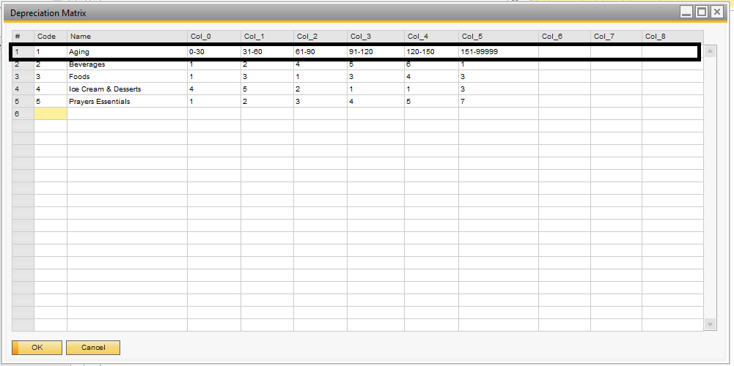

Calculation of Stock Depreciation
- Stock BalanceValue need to sum up value for all Warehouses.

For example: Stock Balance for the Month on September as below (30 September 2014)
Item Group | Item Code | Stock Balance Value | WH | Stock Balance Qty
Beverage | 10001 | 5,000 | SHAWROAD | 1000
 | 10001 | 400 | GR | 300
 | 10003 | 6000 | TB | 100
 | 10004 | 2000 | TB | 500
 | 10005 | 600 | CL | 200
Foods | 20001 | 400 | SHAWROAD | 400
 | 20002 | 6000 | SHAWROAD | 500
 | 20003 | 2000 | GR | 200
 | 20004 | 1000 | GR | 700

- Calculation Total Stock Value for Item Group Beverage.
Total Stock Value for Beverage: 5000 + 400 + 6000 + 2000+ 600 = 14,000

- Get the number of aging days for stock example as below.
- If any stock return from customer , the stock aging should be based on the Original Goods Receipt PO date or Inventory Goods Receipt date.
Total Aging days for Item Code 10001 : 0 - 30 = 4000 Value
Total Aging days for Item Code 10001 : 31 – 60 = 1000 Value
Total Aging days for Item Code 10003 : 0 – 30 = 5000 Value
Total Aging days for Item Code 10003 : 61 – 90 = 1000 Value

Stock depreciation for beverage day 0-30 = 4000 + 5000 X (refer to Matrix table above)
= (4000 + 5000) X 1%
= 90

Stock depreciation for beverage day 31-60 = 1000 X (refer to Matrix table above)
= 1000 X 2%
= 20

Stock depreciation for beverage day 61-90 = 1000 X (refer to Matrix table above)
= 1000 X 4%
= 40

Total Depreciation Amount for Item Group Beverage = 90 + 20 + 40

Log all these information to table of the total Depreciation gross amount and depreciation amount for each group and for each aging category number. All these information for report purpose.

Create Auto JE
- One JE for one Item Group.
- Program need to be auto trigger by end of the month, which is last day of the month.
- Program need to create auto JE. GL Code configure in UDT.
Debit: Provision of Stock Obsolete Account (P&L account) - 103030
Credit: Provision of Stock Obsolete Account (BS account) - 530100

UDT Name: DEPN_STOCK_ACC
Code | Name
Debit | 103030
Credit | 530100
- When create JE, program need to set the reserve date on the JE.
- For example , depreciation of the month August
  - Posting date for JE is on 31 August
  - Reverve date for that JE on 1 September.
- For example , deprecition of the Month September
  - Posting date for JE is on 30 September
  - Reverse date for the JE is on 1 Oct.

Depreciation Report
- Report Format as below.

 | Monthy Depreciation Report - September 2014
ItemGroup |  | 0-30 | 30-60 | 61-90 | 91-120
Beverage
 | Gross Amt | 9000 | 1000 | 1000 | 0
 | Depn Amt | 90 | 20 | 40 | 0
 | Net Amt | 8910 | 980 | 960 | 0

